Blood Donation & Prediction Management System

Submitted in Partial Fulfillment of the requirement for the award of the degree of

Master in Computer Application

Submitted By-

Name-1 Roll no-

Name-2 Roll no-

Name-3 Roll no-

Carried out at-

ASHIRBAD CONSULTANCY

Madhupatna, Cuttack 753010

Under the guidance of

**Dr. Amaresh Sahu**

**H.O.D, Dept. of MCA**

**Ajay Binay Institute of Technology (ABIT)**

**CDA sec – 1, Markat Nagar, Cuttack**

**DECLARATION**

I, [Your Name], solemnly declare that the project report titled " Blood Donation & Prediction Management System " is an authentic work carried out by me under the guidance of [Supervisor's Name] of [organization name], as part of the fulfillment of the requirements for [Degree Name] in [Your Department/Institution Name]. The content presented in this report is original and has not been submitted for any other degree or diploma, nor has it been previously published. All sources of information used in this report have been duly acknowledged and referenced. I further declare that all software programs, algorithms, and methodologies employed in the development of the Blood Bank Management System are original, unless otherwise acknowledged. Any contributions from individuals or organizations towards this project have been duly recognized in the acknowledgment section of this report. I understand the consequences of academic dishonesty, including plagiarism, and affirm that this project report represents my own work and ideas, with due acknowledgment to all sources.

Date: [Date]

Place: [Your Location]

[Your Signature]

**CERTIFICATE**

This is to certify that the project report titled " Blood Donation & Prediction Management System " submitted by [Your Name] is a bona fide work carried out by him/her under my supervision. This report is submitted in partial fulfillment of the requirements for the degree of [Degree Name] in [Your Department/Institution Name].

The content of this report is original and has not been submitted for any other degree or diploma, nor has it been previously published. Proper citations and acknowledgments have been made for all sources of information used in this report.

I hereby attest that to the best of my knowledge, the software programs, algorithms, and methodologies employed in the development of the Blood Bank Management System are original, unless otherwise acknowledged.

I commend [Your Name] for the dedication, effort, and creativity demonstrated throughout the execution of this project.

Date: [Date]

………………………………. …………………………….. ...………………………

**Signature of guide Signature of Principal Signature of HOD**

Dr. Leena Samantray Dr. Amaresh Sahu

Principal, ABIT, Cuttack Assoc. Prof, Dept. Of MCA

**ACKNOWLEGDEMENT**

We would like to express our deepest gratitude to all those who have contributed to the successful completion of this project report on the "Lung Disease Detection and Consultation Web Application." First and foremost, we extend our sincere appreciation to [Supervisor's Name], our project supervisor, for their invaluable guidance, encouragement, and continuous support throughout the duration of this project. Their expertise, insightful feedback, and unwavering commitment have been instrumental in shaping the direction and quality of our work. We are immensely thankful to the faculty and staff of Dept. of MCA, ABIT, whose knowledge-sharing and resources have enriched our learning experience and facilitated the execution of this project. We extend our heartfelt thanks to our friends and peers for their encouragement, motivation, and constructive criticism, which have inspired us to strive for excellence and overcome challenges. We are also grateful to the participants who volunteered to test our web application, providing valuable feedback that helped us refine and improve its functionality and user experience. Last but not least, we express our gratitude to our families for their unwavering support, understanding, and patience during the course of this project. Without the collective effort, support, and encouragement of these individuals and organizations, this project would not have been possible.

**Thank you.**

**[Your Name(s)]**

**[Date]**

ASHIRBAD CONSULTANCY



M.›dhu/at • , Cu‹tark 7s 0io Tel. Nol 943 7 \ 244G5

c mail ashton. [in @gmail.com](mailto:in@gmail.com)

( R«gd No 392/7005 j

TO WHOM IT MAY CONCERN

This is to certify that **[your name and teammates names]** has undergone for the development of a project titled **[project name with slight description]** from **[date]** to **[date]**.

As part of the project they designed various user interfaces and reports by understanding the design structure and implementation. During the period of development they showed good design skill with the attitude to learn new things. Their performance is satisfactory and were able to complete the assigned task on time.

We wish them all the best for their future endeavours.

**vr1

For Ashirbad Consultancy

U: nit of Computer Education, SofMare Development & Data Processing



# INDEX

1. INTRODUCTION
2. PROJECT SCOPE
3. TECHNOLOGIES USED
4. SYSTEM ARCHITECTURE
5. DESCRIPTION OF THE USED TECHNOLOGIES
6. FEATURE DETAILS
7. DEVELOPMENT PROCESS
8. SOURCE CODE
9. DATA MANAGEMENT
10. TESTING
11. DEPLOYMENT
12. FUTURE ENHANCEMENT
13. CONCLUSION
14. BIBLIOGRAPHY

**Introduction to Blood Donation & Prediction Management System**

In an era where the global population is steadily increasing, so too are the prevalence of diseases and health-related challenges. This growth necessitates a corresponding increase in the availability of blood to meet the rising demand. Despite the potential pool of blood donors within the population, only a fraction, often less than 10%, actively participate in blood donation initiatives. This discrepancy between supply and demand underscores the critical need for improved coordination between blood donors and recipients.

The lack of effective communication between these two parties often results in delays in accessing blood, leading to potentially fatal consequences for patients in urgent need. This inefficiency not only compromises patient care but also contributes to the wastage of available blood inventory. To address these challenges, there is an imperative to modernize and automate existing manual processes within blood donation management systems.

The Blood Donation Management System is envisioned as a sophisticated solution to bridge the gap between donors and recipients. By leveraging cutting-edge technology, this system aims to streamline the process of blood donation, distribution, and tracking. Through efficient coordination and real-time communication, it seeks to ensure that blood reaches those in need in a timely and effective manner.

**Need for** **Blood Donation & Prediction Management System**

The current state of blood bank management is characterized by a lack of organization and standardized procedures, leading to inefficiencies and limitations in accessing blood resources. Donors face restrictions in accessing blood from banks other than where they have previously donated, further exacerbating the challenges in blood distribution. Additionally, the integration of blood banks within hospital systems creates siloed operations with varying limitations and inefficiencies.

Several key challenges persist within the existing blood bank management framework:

**Low Efficiency and Quality:** The fragmented nature of blood banks, coupled with a low donor-to-bank ratio, results in suboptimal efficiency and quality standards. This inefficiency contributes to the wastage of blood and its components, undermining the potential impact of blood donation efforts.

**Scarcity of Rare Blood Groups:** The decentralized nature of blood banks exacerbates the challenge of accessing rare blood groups, further limiting the availability of critical blood supplies for patients with specific needs.

**Unavailability During Emergencies:** The lack of a centralized system for blood distribution hampers the timely availability of blood during emergencies, potentially compromising patient care and outcomes.

**Limited Awareness:** There exists a general lack of awareness among the population regarding the importance of blood donation and transfusion. This lack of awareness further reduces the pool of potential donors, exacerbating the challenges faced by blood banks.

**Deaths Due to Blood Shortages:** Inadequate access to blood during surgical procedures and medical emergencies can result in fatalities, highlighting the critical importance of addressing blood shortage issues effectively.

To address these pressing challenges, there is a compelling need for the implementation of a comprehensive Blood Donation Management System. Such a system would streamline blood donation processes, improve access to blood resources, enhance awareness, and ultimately save lives by ensuring timely access to blood for patients in need. By leveraging modern technology and standardized protocols, the Blood Donation Management System aims to revolutionize blood bank operations, optimize resource utilization, and mitigate the adverse consequences of blood shortages in healthcare settings.

**Aim of the Project:**

The primary objective of this project is to establish a comprehensive blood donation service within the city. The Blood Bank Management System (BBMS) is envisioned as a web-based platform designed to efficiently store, process, retrieve, and analyze critical information related to administrative and inventory management within a blood bank setting.

**Key aims of the project include**:

**Donor Information Management**: To centralize and maintain accurate records of blood donors, including their personal details and blood group information, ensuring swift access to vital donor data when needed.

**Inventory Management**: To effectively manage and monitor the inventory of different blood groups available within the blood bank, facilitating optimized resource allocation and timely response to blood requests.

**Transparency and Efficiency**: To promote transparency in blood donation processes and streamline the process of obtaining blood from the blood bank, thereby eliminating hassles and reducing the likelihood of corruption in the system.

**Enhanced Effectiveness**: To enhance the overall effectiveness of blood bank management by implementing standardized procedures and leveraging technology to automate manual processes, ultimately ensuring seamless operations and improved service delivery.

By fulfilling these aims, the project seeks to establish a robust and efficient blood donation system that not only meets the immediate needs of the community but also lays the foundation for sustainable blood management practices in the long run.

**History of Blood Donation Management Systems**

The concept of blood banks, organizations dedicated to collecting, storing, processing, and transfusing blood, has its roots in the early 20th century. During World War I, the feasibility of storing blood for transfusion was demonstrated, laying the foundation for the development of the first official blood bank in 1932. Prior to the establishment of blood banks, medical practitioners relied on ad hoc methods, such as determining the blood types of patients' relatives and friends, to source compatible blood for transfusions.

The 1940s marked a significant turning point in blood banking with the discovery of numerous blood types and advancements in cross-matching techniques. This period saw the rapid evolution of blood banking into a specialized field, with responsibility for transfusion-related tasks gradually shifting from physicians to trained technicians and clinical pathologists. The ability to store blood and its components for future use paved the way for groundbreaking medical innovations, including artificial kidneys, heart-lung pumps for cardiac surgery, and exchange transfusions for infants with erythroblastosis fetalis.

Whole blood, typically donated in units of approximately 450 ml, has a limited storage lifespan. However, advancements in blood banking have enabled the separation and storage of various blood components, such as red blood cells, plasma, and platelets, for extended periods. These components serve specific medical purposes, including controlling bleeding, correcting anemia, and augmenting blood volume in cases of shock.

Despite these advancements, blood banks often face challenges in maintaining an adequate supply of blood donations. The development of apheresis technology has helped alleviate this issue by allowing the selective extraction of desired blood components from donors, while returning the remaining blood components to the donor. This technique enables the collection of large quantities of specific blood components from a single donor, thereby enhancing the efficiency of blood donation programs.

In summary, the history of blood donation management systems is a testament to the ongoing efforts to improve the efficiency, safety, and accessibility of blood transfusion services, ultimately saving countless lives through the provision of vital blood products.

**Existing System vs. Proposed System:**

**Existing System**: The operation of the blood bank is currently maintained through manual processes, presenting several challenges:

The manual operation is tedious, time-consuming, and space-consuming, leading to inefficiencies in blood bank management.

Manual data entry increases the risk of errors, compromising the accuracy and reliability of records.

There is a significant risk of document loss over time, making record maintenance difficult and unreliable.

Data recorded manually may lack precision and accuracy, particularly during testing or when acquiring details related to blood bank management.

Managing blood stock and daily transactions without computerization poses considerable challenges, hindering efficient operation.

**Proposed System**: The proposed system, the Blood Bank Management System, aims to address the limitations of the existing manual system by introducing a digital platform designed to streamline blood bank operations:

The system is designed to facilitate the demand for blood by enabling efficient communication between the blood bank administrator, donors, and recipients.

It provides a procedural approach to bridge the gap between recipients, donors, and the blood bank, ensuring timely access to blood when needed.

The application serves as a common platform for recipients, donors, and the blood bank, ensuring the fulfillment of blood requests promptly.

Integration and Enhancement: The proposed system seeks to integrate and enhance the existing blood bank operations, thereby overcoming the shortcomings of manual processes:

By transitioning to a digital platform, the proposed system aims to eliminate the inefficiencies associated with manual operation, making blood bank management more streamlined and effective.

Automation of data entry and management processes reduces the risk of errors and ensures the accuracy and reliability of records, enhancing overall operational efficiency.

The digital platform offers improved data storage and retrieval capabilities, minimizing the risk of document loss and simplifying record maintenance for blood bank administrators.

By computerizing blood stock management and daily transactions, the proposed system enables more efficient inventory management, ensuring optimal utilization of available resources and timely response to blood requests.

**Specifications:**

**3.1 Hardware Requirements**:

Processor: Intel Pentium or Higher Version

RAM: Minimum 1GB

Hard Disk: 10GB and above

**3.2 Software Requirements:**

Software: Python 3.3 or greater

Framework: Django 3.0 or greater

Database: SQLite

Supported Browsers: Google Chrome / Mozilla Firefox / Internet Explorer

Editor: Atom / Visual Studio Code

Operating System: Windows, MacOS, or Linux (32/64 bit)

**Functional Requirements:**

The Functional Requirements Specification outlines the key operations and activities that the system must be capable of performing. These requirements include:

**Management of Donor Information:**

The system should be able to manage and maintain the information of blood donors, including personal details, contact information, and medical history.

**Management of Employee Information:**

Ability to manage and maintain information about employees involved in blood bank operations, including roles, responsibilities, and contact details.

**Description of System Operations:**

Detailed descriptions of operations performed by the system, such as donor registration, blood collection, inventory management, and blood distribution.

**Description of Workflows:**

Define workflows within the system, outlining the sequence of steps involved in various processes, such as blood donation, testing, and distribution.

**Storage Area and Data Storage Management:**

Ability to maintain storage areas for blood and blood products, ensuring proper storage conditions and tracking inventory levels.

**Data Entry Authorization:**

Specify who has permission to enter data into the system, ensuring data integrity and security.

The Functional Requirements Specifications are designed to be understandable by a general audience, without requiring extensive technical knowledge. These documents serve to guide the development process by articulating the system's operational capabilities and functionalities.

Additionally, software requirement specifications play a crucial role in optimizing development efforts and minimizing costs by providing a clear roadmap for achieving project goals. Quality assurance and control are essential aspects of software development, with the following factors used to measure software quality:

**Reliability:**

Evaluate the system's ability to consistently deliver accurate results under various operating conditions, ensuring dependability and performance.

**Maintainability:**

Assess the ease of maintaining and updating the software, including adding new features and technologies, to ensure cost-effective maintenance and future enhancements.

**Usability:**

Measure the ease of use of the application, focusing on user-friendly interfaces for input, operation, and interpretation of output.

**Portability:**

Consider costing, technical, and behavioral factors related to porting the software to different environments, ensuring compatibility and adaptability across platforms.

Top of Form

**Non-Functional Requirements:**

The evaluation of satisfactory performance may not necessarily be conducted on the system where the program is initially developed, tested, or installed.

System Design:

4.1 Introduction: System design marks the initial stage in devising the fundamental approach to solving a problem. It involves the determination of overall structures and styles, with the system architecture playing a pivotal role in organizing the system into subsystems. The architecture sets the context for subsequent detailed decisions made during the design process. Developers make decisions about problem-solving approaches, starting from high-level concepts and gradually delving into finer details.

4.1.1 Architectural Diagram: Every software system requires a design structure that delineates its functionality, known as architecture. In database management systems (DBMS), database architecture defines the interaction of the database with the system and the languages used. The database architecture typically comprises three levels:

External level

Conceptual level

Internal level

4.1.2 Data Flow Diagram: A Data Flow Diagram (DFD) offers a graphical representation of the flow of data through an information system. Data Flow modules depict how data moves through a sequence of processing steps, with transformations occurring at each stage. These modules provide an intuitive depiction of data processing within a system, representing functional processing, data stores, and data movements between functions.

4.1.3 Use Case Diagrams: The Use Case module serves as a catalog of system functionality, described using UML use cases. Each use case represents a single, repeatable interaction that a user or actor experiences when interacting with the system. Use cases typically include scenarios detailing interactions between the actor and the system, along with documented results and exceptions from the user's perspective. Use cases may be interlinked to handle exceptional conditions and form coherent pieces of functionality that the system can provide by interacting with actors.

User

Bloodbank Management System

Admin

Employee

User

View

Update

Modify

Insert user and blood details

Register

Donate

Request

Database

Top of Form

BLOOD BANK MANAGEMENT SYSTEM

Hire Employees

Maintain Databases

Keep record of blood groups

Accept or delete requests

Register donor

Register into system

Add blood packets to bloodbank

Register his/her details

Donates blood

Requests for blood

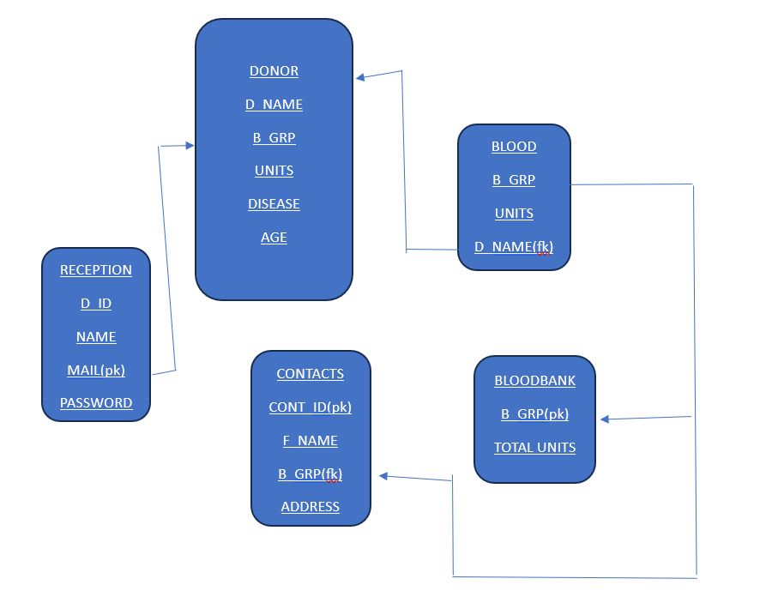

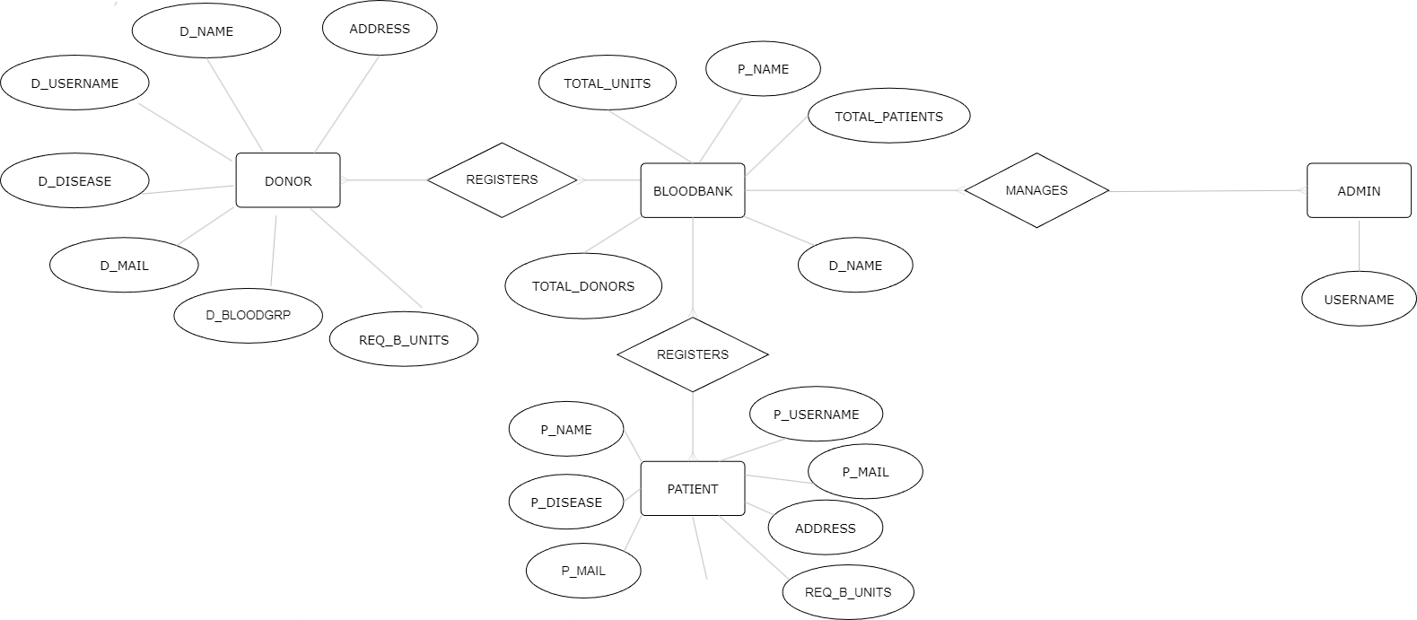

**Conclusion:**

In an era characterized by rapid technological advancements, the proposed system emerges as a crucial tool in expediting the delivery of essential blood supplies to those in need, particularly during emergencies. By leveraging web-based technology, the system facilitates seamless communication and synchronization between blood donors and blood banks, ensuring timely access to life-saving resources.

The web application serves as a vital platform for connecting donors with blood banks, enabling efficient coordination and communication, especially during critical situations. Moreover, it empowers users to reach out to potential donors in times of emergency, further enhancing the responsiveness of the system.

Central to the system's functionality is its database, which serves as the backbone for storing and managing crucial information about both donors and recipients. Regular checks and maintenance of the database are essential to ensure its integrity and reliability, thereby guaranteeing the smooth operation of the system.

In essence, the proposed system not only streamlines the process of blood donation and distribution but also plays a pivotal role in saving lives by facilitating timely access to blood resources. Its implementation represents a significant step forward in leveraging technology to address critical healthcare challenges and make a meaningful impact on society.

Top of Form